Item | Recommended/ Example item | Other Information
Marlins Swim Hat | 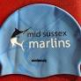 | Have a spare
Goggles | 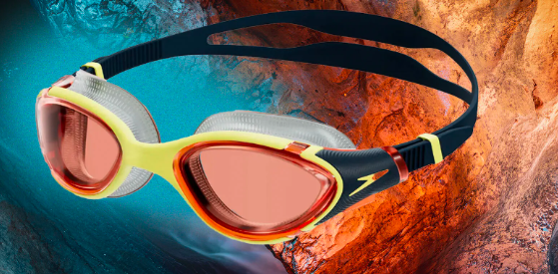 | Have a spare
Short Fins | 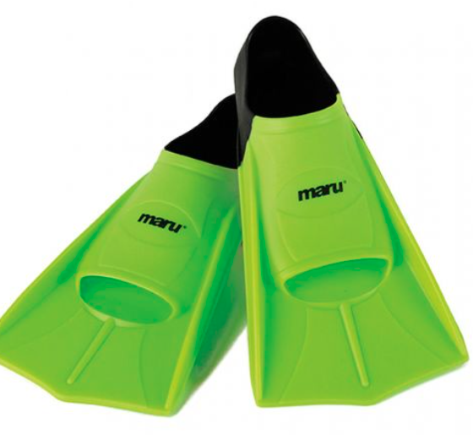 | Write name on them.
Mesh Bag | 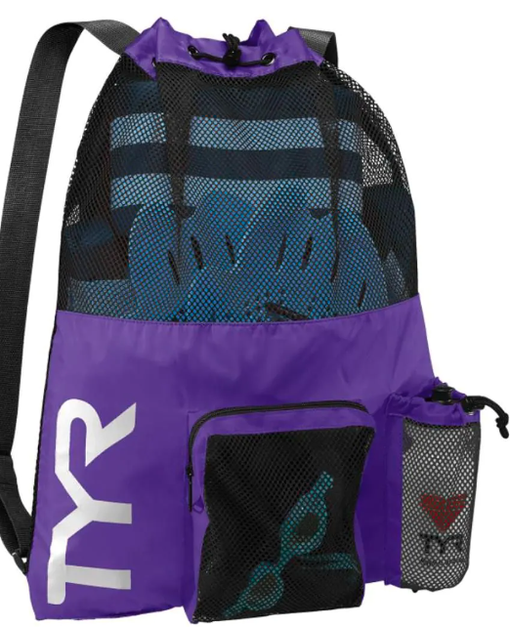 | Write name on
Kickboard | 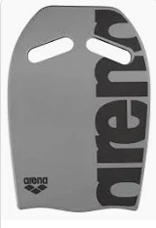 | Write name on.
Pull Buoy | 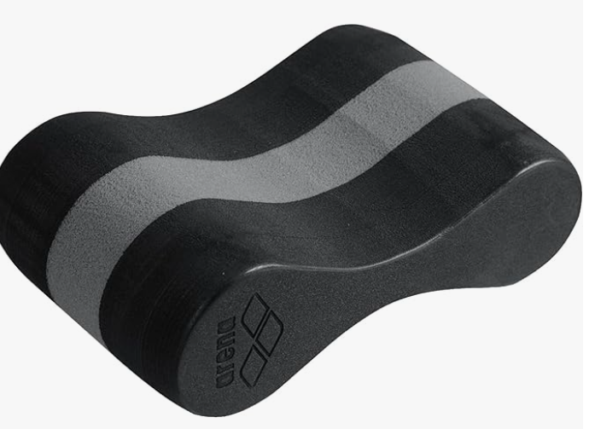 | Write name on
Hand Paddles | 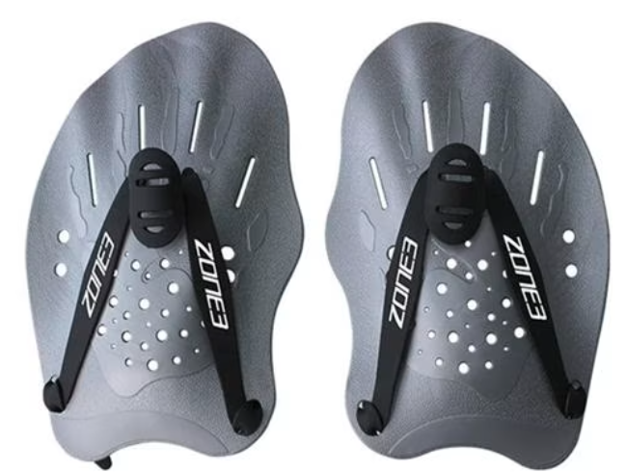 | Write name on
Snorkel | 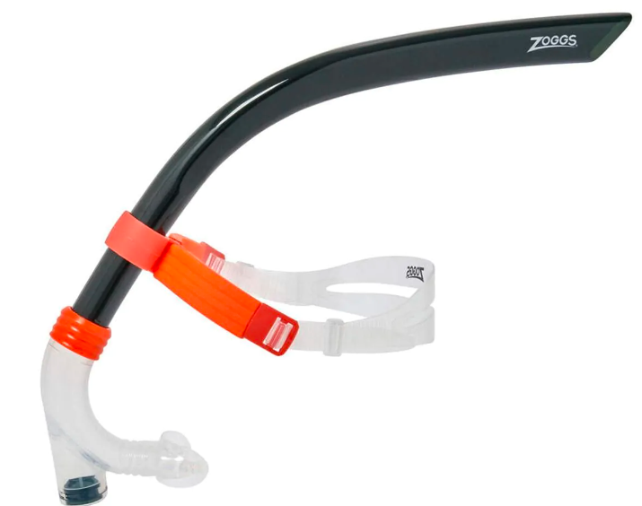 | Write name on

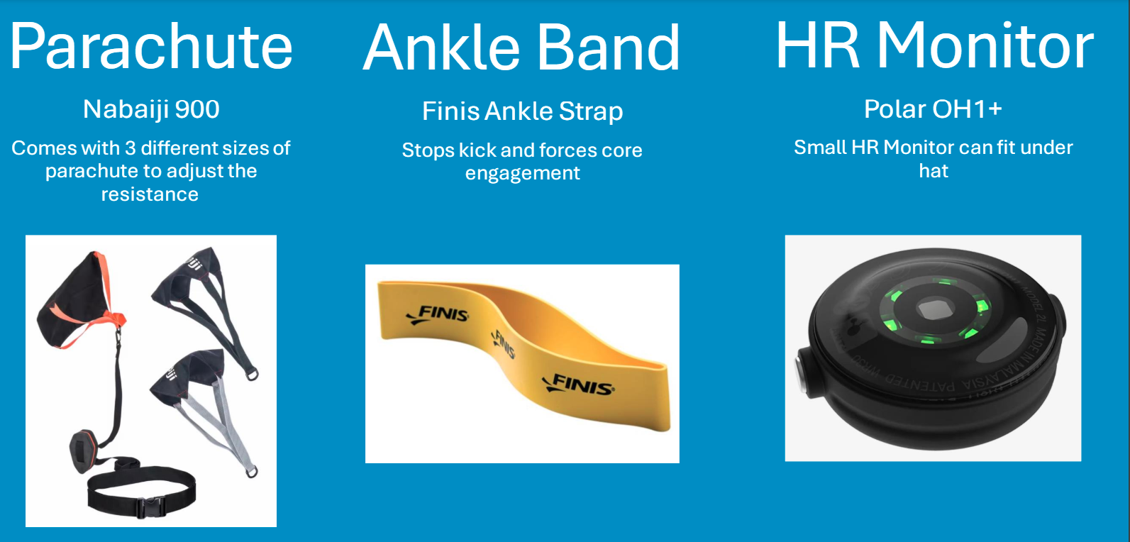
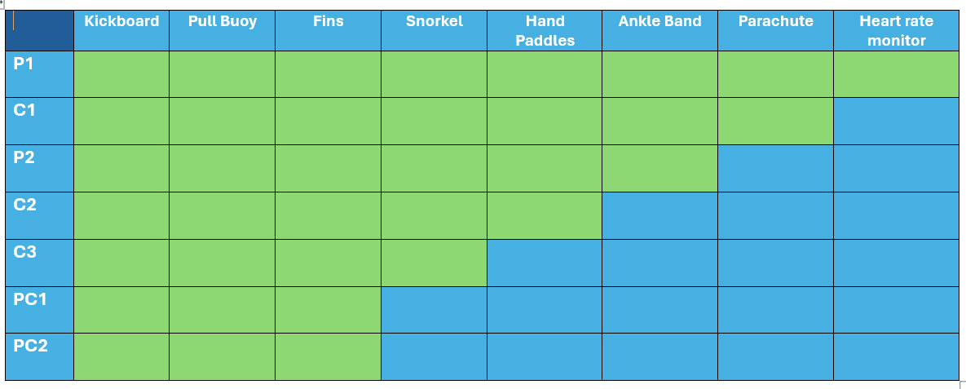
Please write the swimmer’s name on all kit to ensure that lost or forgotten kits can be returned

Kit suppliers-
Arena, Speedo, TYR, Swimzi, Maru, Pro Swimwear, Decathlon, Amazon, Allens of Kingsbury, Funkita, Swim Shop, Finis, Zoggs, Swim Stop, JP Lennard, Maudsport. Swim Path and many more.

